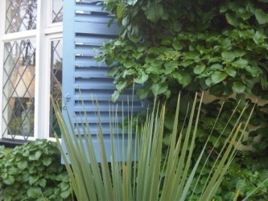

The Guest Suite

20 Rectory Park, Sanderstead, Surrey, CR2 9JN

Tel: +44 (0)20 8657 9208 Email: [irenesc@live.co.uk](mailto:irenesc@live.co.uk)

**Booking Form**

Names of guests: Age if under 18

*Guest 1*...............................................................................................................

*Guest 2*...............................................................................................................

*Guest 3*...............................................................................................................

*Guest 4*...............................................................................................................

*Guest 5*...............................................................................................................

Please give the full postal address of the guest booking The Guest Suite:

...........................................................................................................................

...........................................................................................................................

Home telephone number...................................Mobile number..............................

Email address.......................................................................................................

Arrival date ......./......../......... Approximate arrival time ............. am / pm

Departure date ......../......../........

Registration number of vehicle/s...........................................................................

Flight number and arrival airport / Ferry port .........................................................